**Visual Studio Code Setup for C/C++ on Windows**

1. Download & Install Visual Studio Code
2. Download and Install MinGW (Minimalist GNU for Windows)
3. Add MinGW to the environment variable - PATH
4. Setup CodeRunner in VSCode
5. **Download & Install Visual Studio Code**
   1. Visit <https://code.visualstudio.com/download>
   2. Click ***User installer x64*** to download, you will get following executable on your machine: ***VSCodeUserSetup-x64-1.86.2.exe***
   3. Double click on executable, following dialog will appear, accept the agreement & click Next

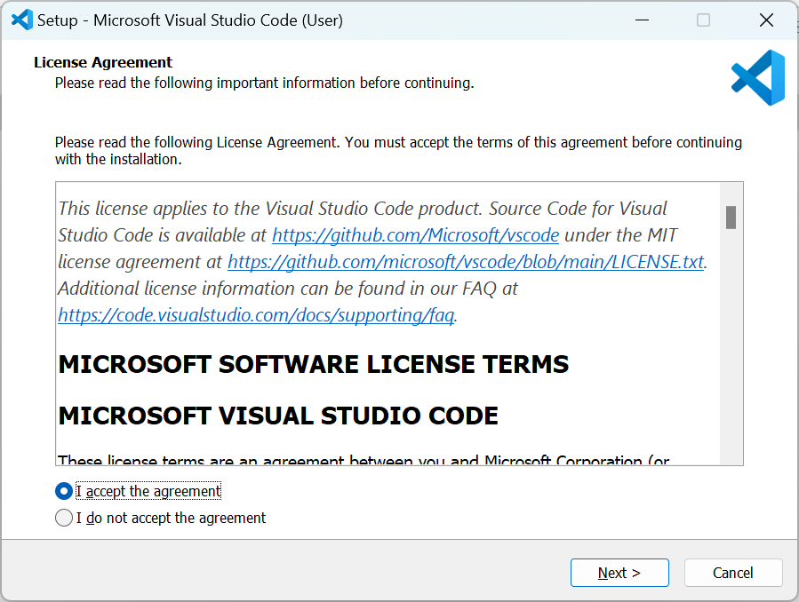

* 1. Choose the directory to install (make sure selected directory has write permission), click Next

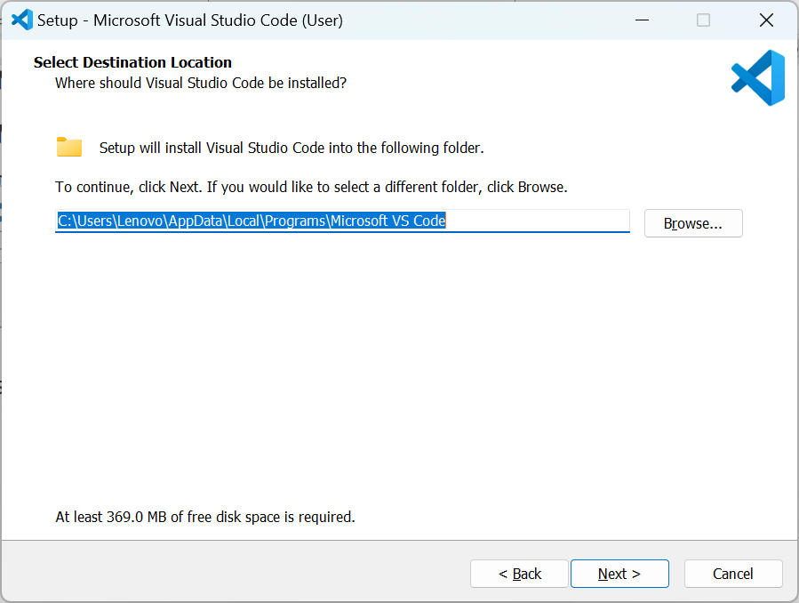

* 1. Next

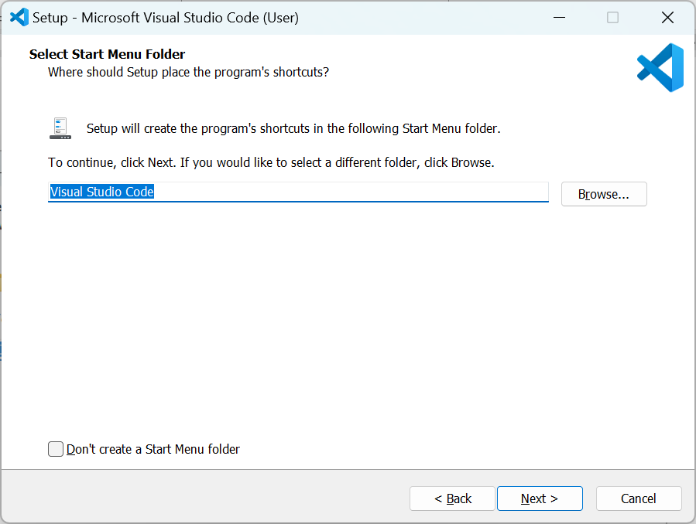

* 1. Next

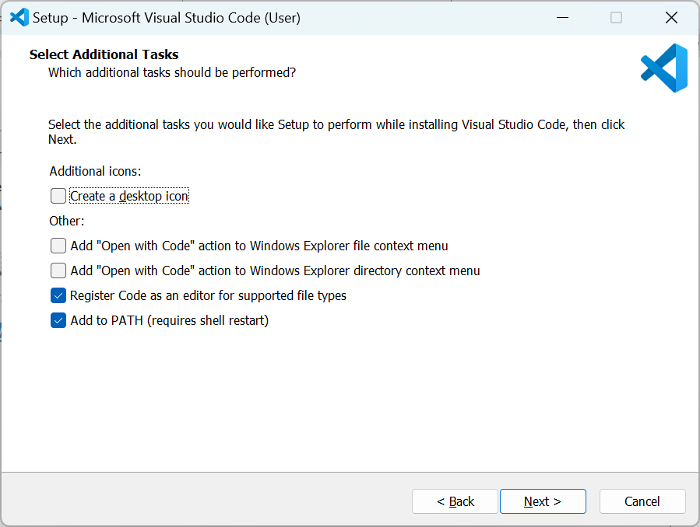

* 1. Next

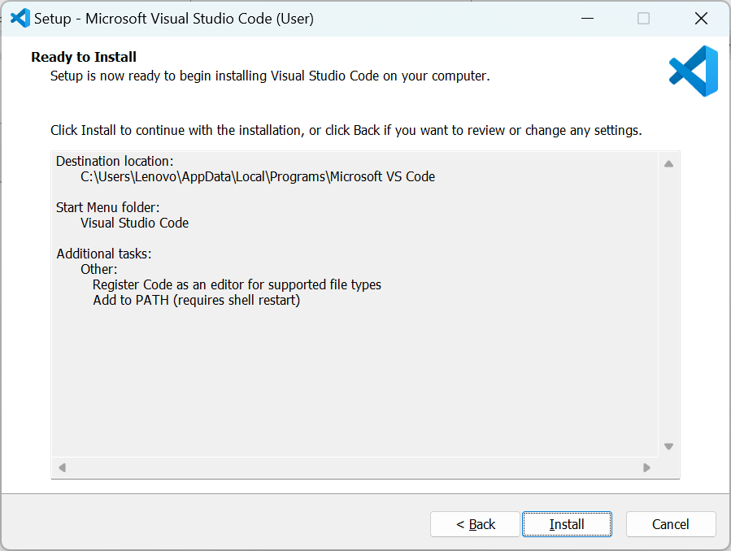

* 1. Click Install

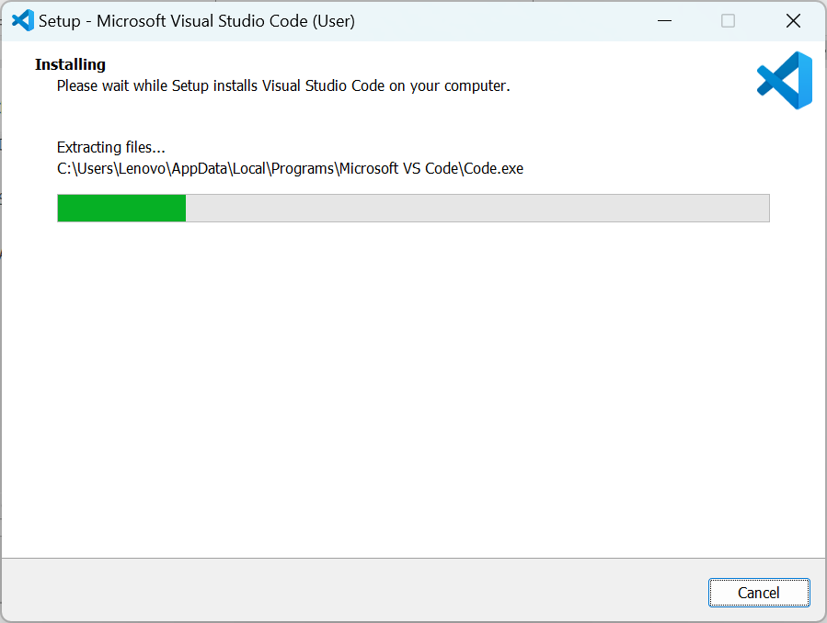

* 1. You are done, Click Finish

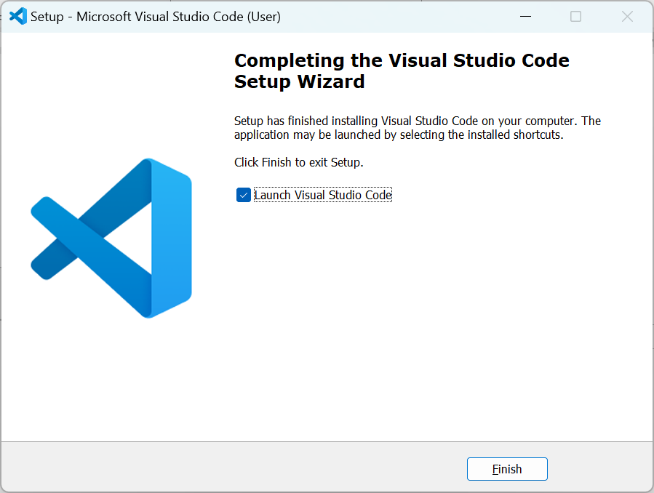

* 1. VS Code is launched

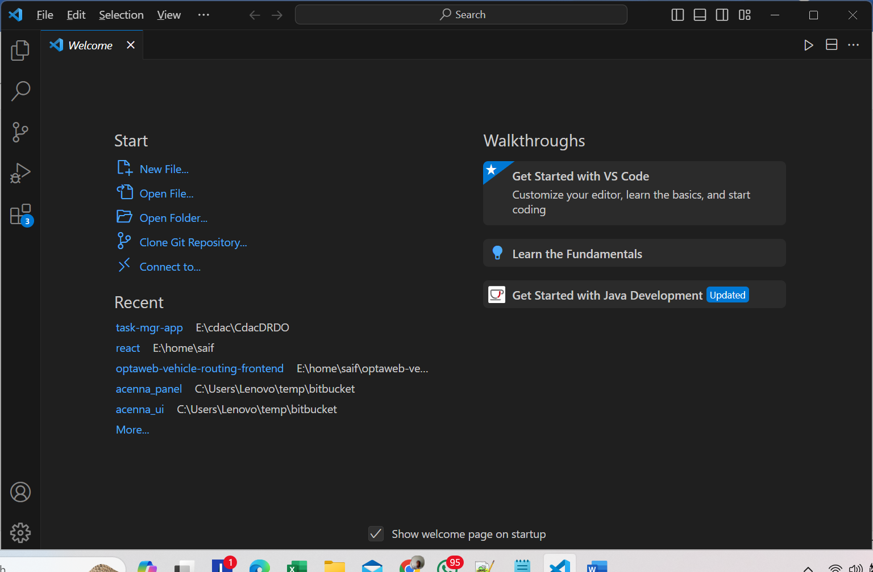

1. **Download and Install MinGW (Minimalist GNU for Windows)**
   1. Visit <https://sourceforge.net/projects/mingw/> and download, you will get *mingw-get-setup.exe*
   2. Double Click on executable

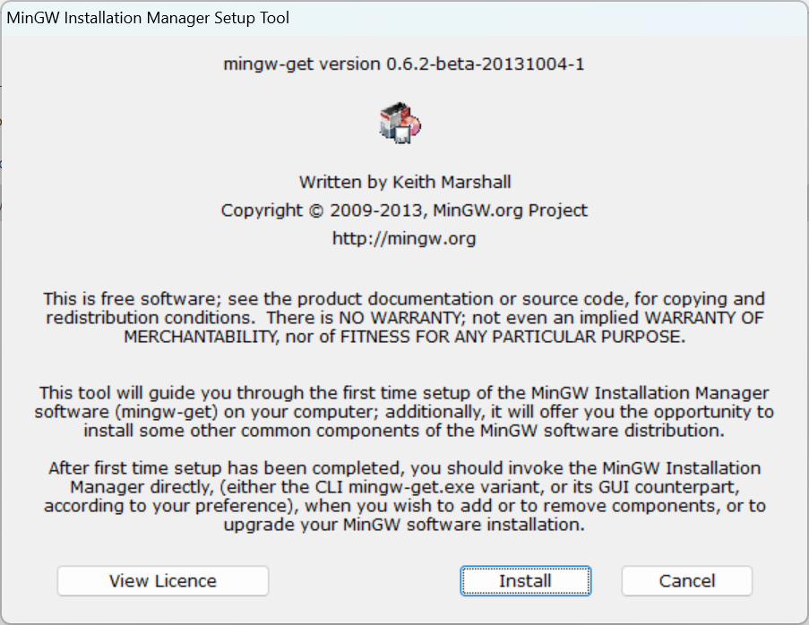

* 1. Click Install

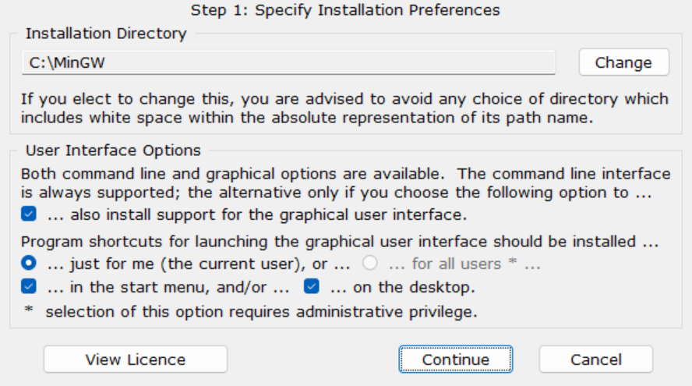

* 1. Continue

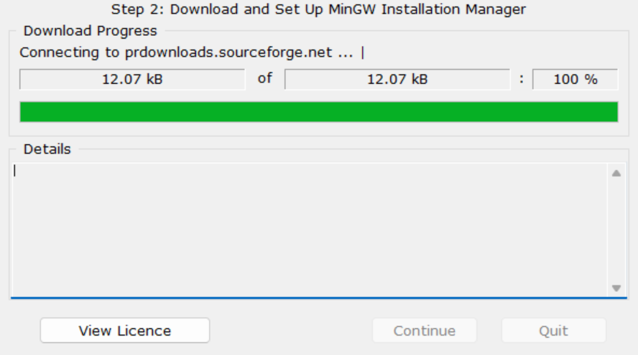

* 1. Continue

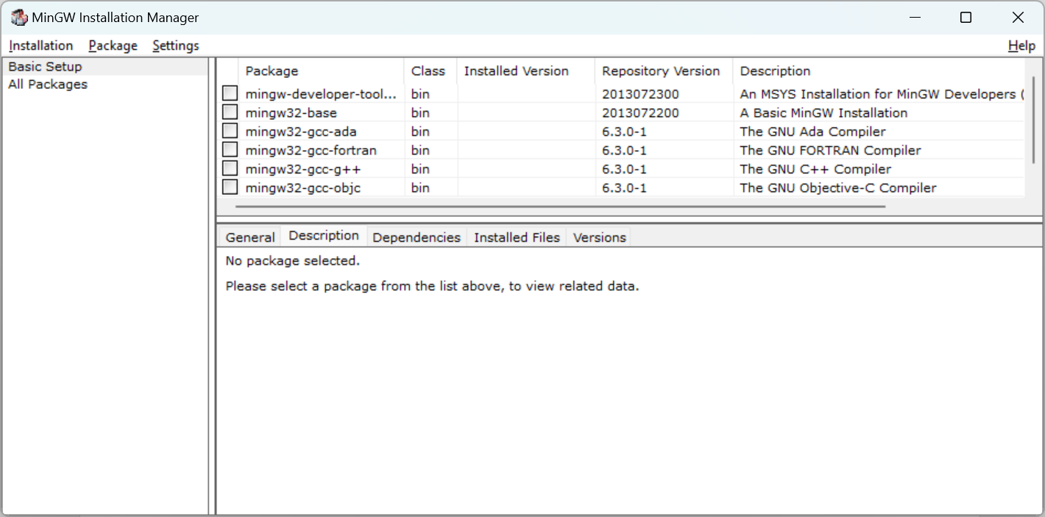

* 1. Select *mingw32-base* & *mingw32-gcc-g++*, Click on *Installation/Apply changes*

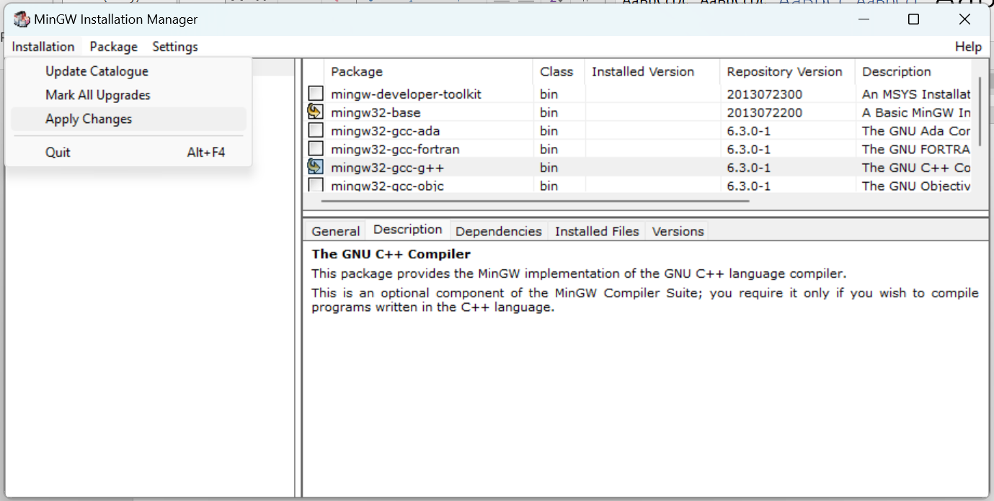

* 1. Click on Apply

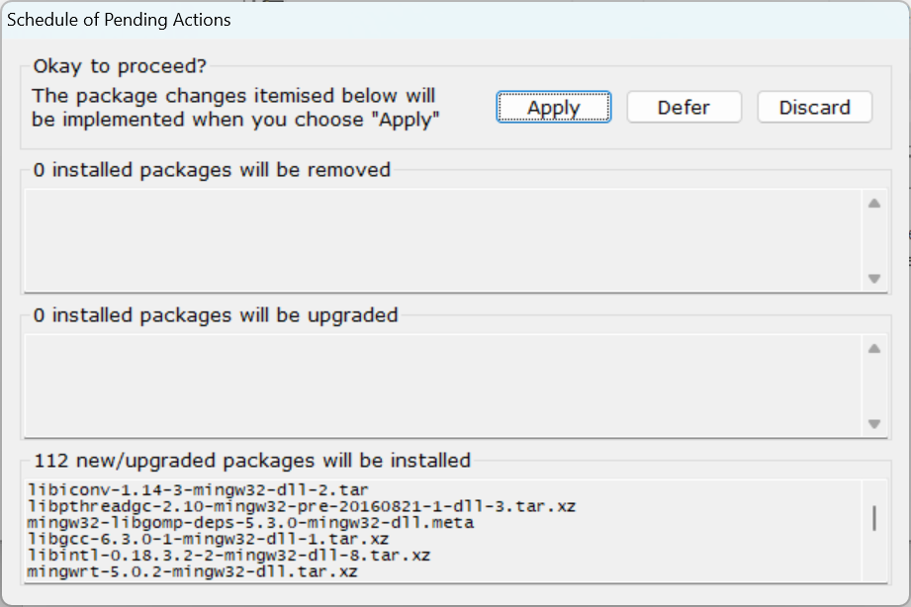

* 1. Installation is in progress

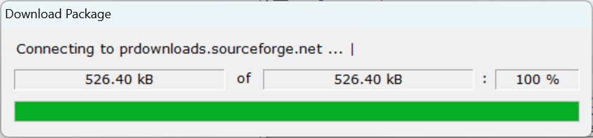

* 1. Final dialog , click Close & its done

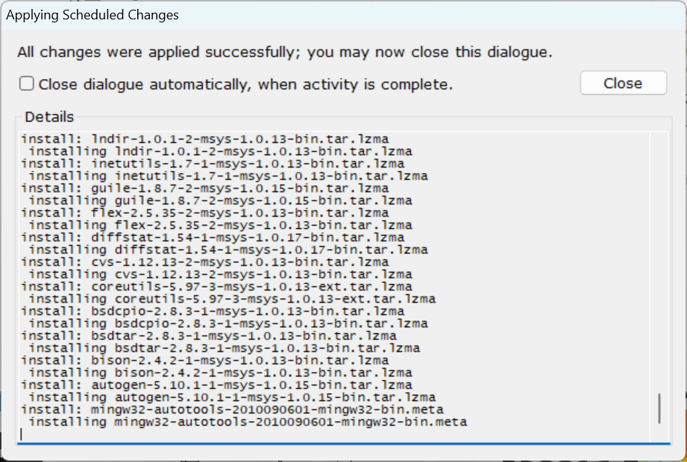

1. **Add MinGW to the environment variable - PATH** 
   1. Default MinGW installed to *C:\MinGW\bin*, if you have chosen to install to different location then copy the path till bin directory.
   2. Open *System Properties* (You can type “env” to search box and then click on the item “edit the System environment variables”)

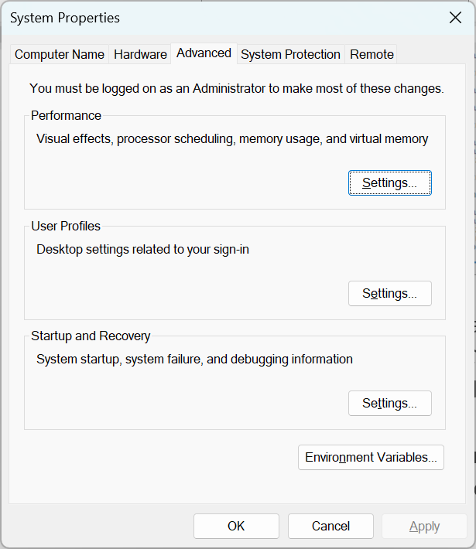

* 1. Under the tab *Advanced*, click *Environment Variables*

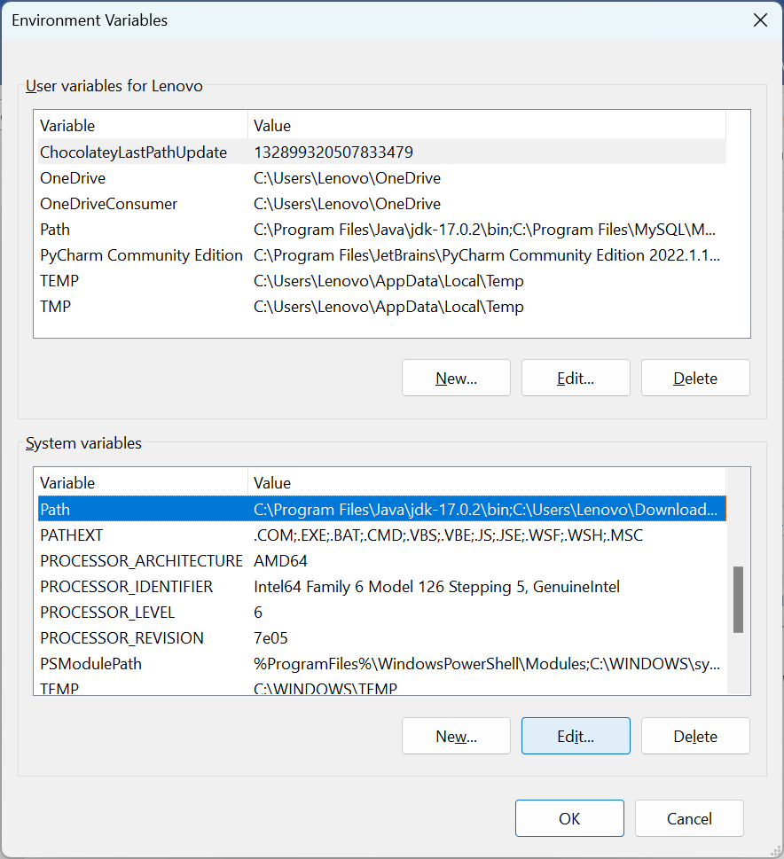

* 1. Select *Path* & Click on *Edit,* New dialog will open

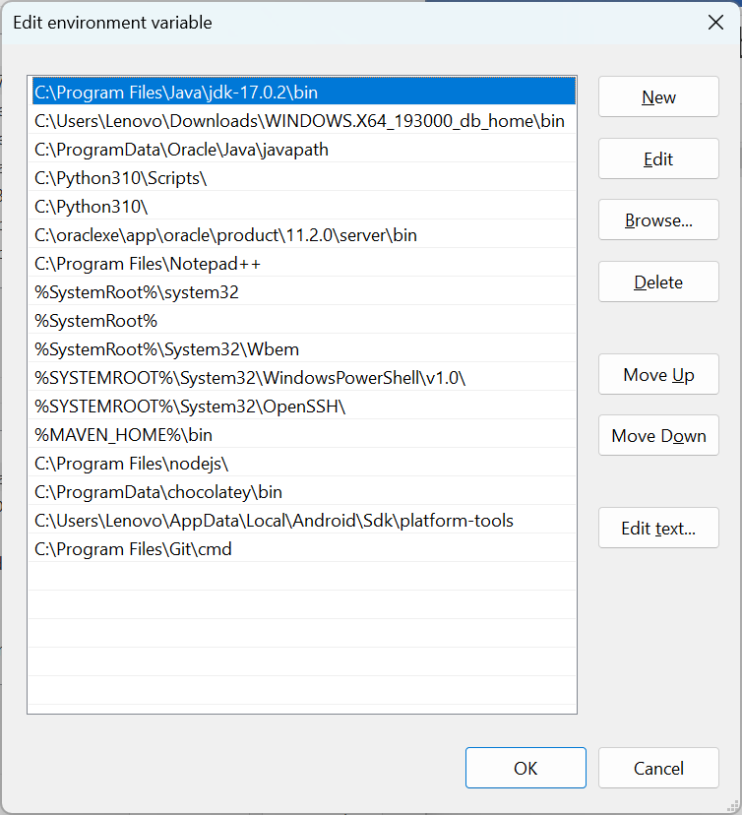

* 1. Click on *New* & add *C:\MinGW\bin.* Ok and close all dialogs.

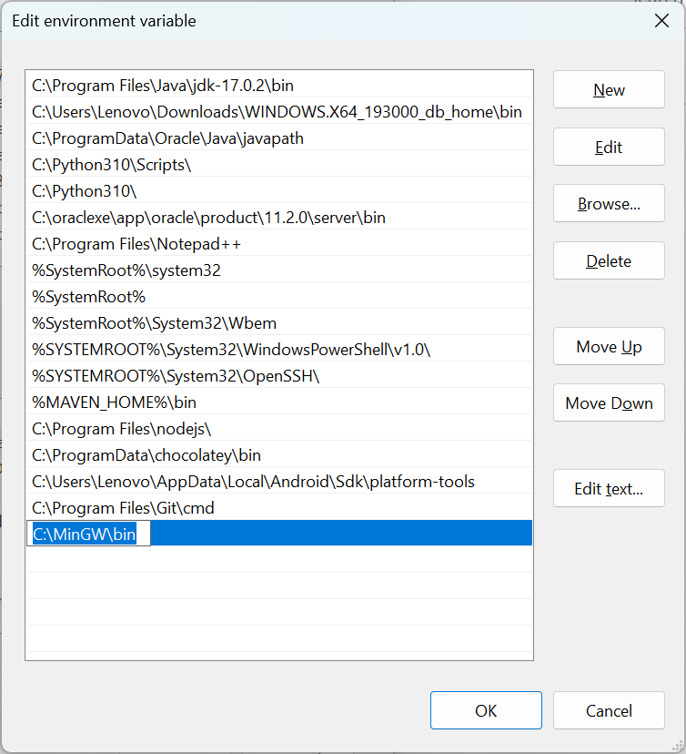

* 1. Done, verify the MinGW from command prompt

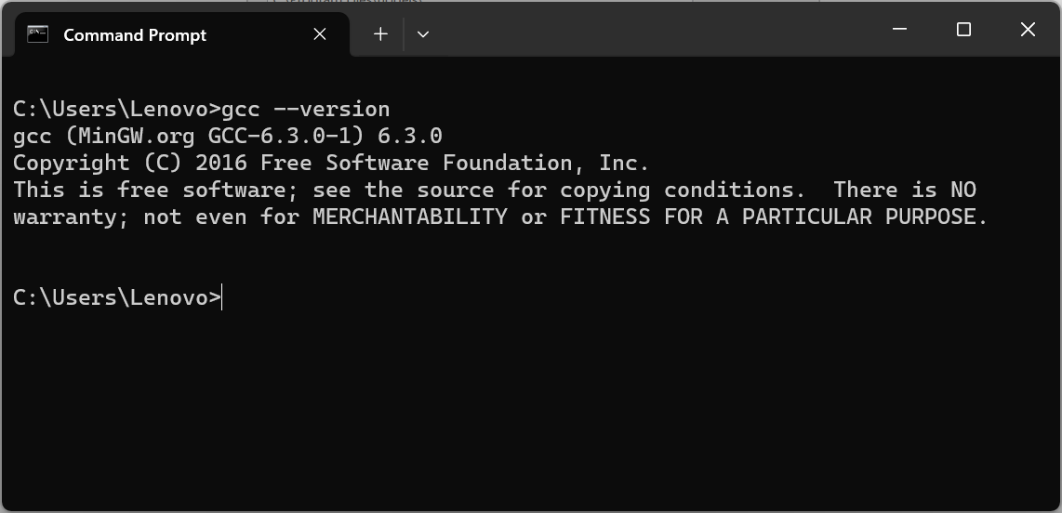

1. **Now Open VS Code, Go to Extension, Search for *“Code Runner”***
   1. Install Coder Runner if not installed already

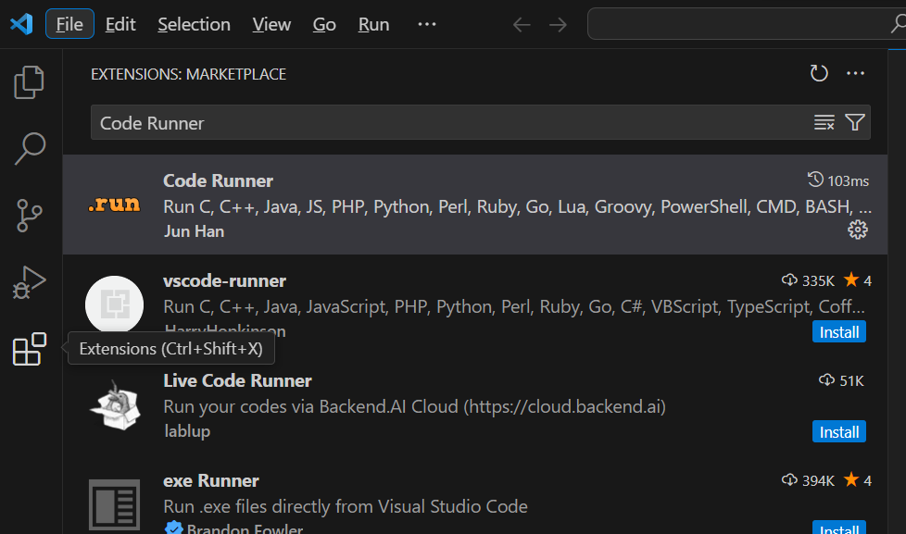

* 1. Open settings, search “code runner” and set below configurations: (Run in Terminal, Save File Before Run)

